***ADAPTIVE CRUISE CONTROL***

Based on: Simulink and Arduino UNO

By:

**Rajnish Tailor 110006068**

**Dhaval Patel 105174255**

**(TEAM 4)**

Guidance of:

**Dr. Rashid Rashidzadeh**

**(Professor)**

and

**Manya Mehta and Ankit Mehta**

**(G.A.)**



Comp. Meth. & Modeling for Engineering (GENG-8030-1-R)

Faculty of Engineering University of Windsor, Canada

Winter 2020 Semester

**Overview**

Cars on the road are increasing day-by-day and so are their features. Adaptive cruise control is a system which is fixed inside the vehicle, when activated can determine as well as control the speed of the vehicle. The system designed in this project works on Simulink environment, a product of MathWorks, and is executed in the real-time with the help of an Arduino UNO micro-controller. The project consists of 2 basic modes;

* The Manual Mode: Speed can be controlled and fixed manually
* The Adaptive Cruise Mode: Speed is determined by the system depending on the data it receives from the distance sensor (Ultrasound) on the vehicle in real-time

There are two modes each of them have a particular and selection of modes is left up to the user completely. Upon selection of a particular mode a set of software actions take place which perform the assigned task.

**CONTENTS**

|  |  |  |  |  |
| --- | --- | --- | --- | --- |
| ***Disclaimer*** | | | | *Page No.* |
| 1 | Introduction | | | 6 |
| 2 | Design and Methodology | | | 6 |
|  | 2.1 | Simulink | | 6 |
| 2.2 | Component Description | | 6 |
| 2.2.1 | Hardware | 7 |
| 2.2.2 | Software and Simulink Blocks | 9 |
| 3 | Implementation | | | 13 |
| 3.1 | Module 1 | | 13 |
| 3.1.1 | Hardware | 13 |
| 3.2 | Module 2 | | 16 |
| 3.2.1 | Layer 1 | 16 |
| 3.2.2 | Layer 2 | 17 |
| 3.2.3 | Layer 3 | 18 |
| 4 | Challenges Faced | | | 19 |
| 5 | Functioning | | | 21 |
|  | 5.1 | Block Diagram of Project | | 21 |
| 5.2 | Flowchart of Adaptive Cruise Control | | 21 |
| 5.3 | LCD S-Block Code | | 21 |
| 5.4 | MATLAB Code for Speed Control | | 21 |
| 6 | Results | | | 23 |
| 7 | References | | | 24 |

**List of Pictures**

|  |  |  |
| --- | --- | --- |
| **Figure Number** | **Caption** | **Page Number** |
| Fig. 2.1.1 | Simulink Space | 6 |
| Fig. 2.1.2 | Simulink Librar | 6 |
| Fig. 2.2.1.1 | Arduino UNO | 7 |
| Fig. 2.2.1.2 | 16x2 LCD | 7 |
| Fig. 2.2.1.3 | Push Buttons | 8 |
| Fig. 2.2.1.4 | Resistor | 8 |
| Fig. 2.2.1.5 | Potentiometer | 8 |
| Fig. 2.2.1.6 | HC-SR04 | 9 |
| Fig. 2.2.1.7 | Breadboard | 9 |
| Fig. 2.2.2.1 | Pin Blocks | 9 |
| Fig. 2.2.2.2 | Latching Layer 1 | 10 |
| Fig. 2.2.2.3 | Latching Layer 2 | 10 |
| Fig. 2.2.2.4 | Data Store | 11 |
| Fig. 2.2.2.5 | LCD Module | 11 |
| Fig. 2.2.2.6 | Ultrasound | 12 |
| Fig. 2.2.2.7 | Pulse Generator | 12 |
| Fig. 3.1.1.1 | Buttons | 13 |
| Fig. 3.1.1.2 | LCD | 13 |
| Fig. 3.1.1.3 | Sensor | 14 |
| Fig. 3.1.1.4 | Final Assembly | 14 |
| Fig. 3.1.1.5 | Demo | 14 |
| Fig. 3.1.1.6 | Adaptive | 15 |
| Fig. 3.1.1.7 | Adaptive Demo | 15 |
| Fig. 3.2.1 | Layer 1 | 16 |
| Fig. 3.2.2 | Layer 2 | 16 |
| Fig. 3.2.3.1 | Sub-Section 3a | 17 |
| Fig. 3.2.3.2 | Sub-Section 3b | 17 |
| Fig. 4.1 | LCD | 18 |
| Fig. 4.2 | Data Store | 19 |
| Fig. 4.3 | Arduino Pins | 19 |
| Fig. 4.4 | Latch | 20 |
| Fig. 4.5 | Continuous Decrement | 20 |
| Fig. 5.1 | Block Diagram | 21 |
| Fig 5.2 | Flowchart | 21 |

**Introduction**

The system developed consists of two modes which are capable of manipulating the speed of the vehicle the system is installed in. The modes have a specific task, which when selected variate the speed. The manual mode increases or decreases the speed on manual actions/button at a particular rate and the adaptive system changes the speed depending upon the distance between the parent vehicle and the successive vehicle.

The whole project runs on the Simulink background and is executed by the onboard embedded system Arduino. The manual system contains a logic set which decides the rate of increase or decrease on a particular trigger, whilst the adaptive mode runs as an adjustable system which monitors and varies the speed continuously. He system uses a latching logic internally which makes sure that there is continuous execution of a particular section after its selection irrespective of the trigger(s).

**Design and Methodology**

**2.1 Simulink**

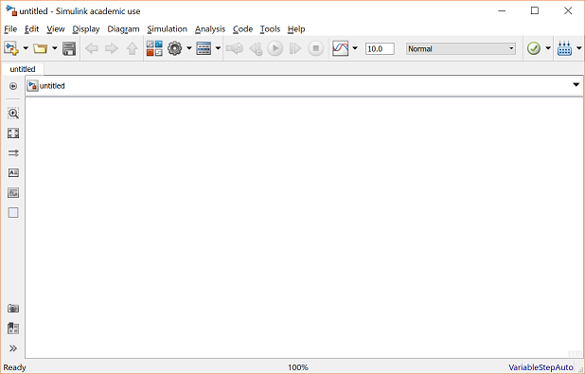Simulink is a graphical simulation software in MATLAB. It can perform any action or run any program or task, but in a graphical format. It is as good as programming in MATLAB, rather better, as one can see and visualize the different sections and components used as well as monitor the signal flow. It contains a library of different blocks we can use to design a project. The blocks contain real time parameters as well as can perform a real time execution of the data. Each block has a specific purpose which is described in the description of the same. The description gives you the idea that what are different attributes of the block viz. data-type, inputs, outputs etc. With the help of all these an appropriate block can be chosen for a task.

Fig. 2.1.1 Simulink Space [1]

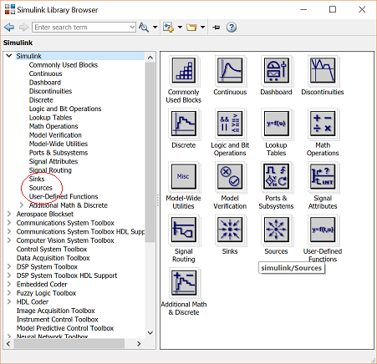Fig. 2.1.2 Simulink Library [2]

**2.2 Component Description**

**2.2.1 Hardware**

* Arduino UNO: - The Arduino UNO is a microcontroller which can perform asks when programmed. It had a ATMEGA328P chipset from Atmel. The on-board system has a 16MHz crystal and is equipped with digital I/O, analog input, PWM output, serial communication and ICSP.

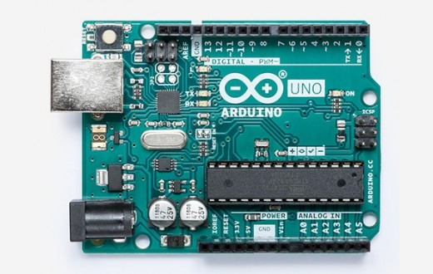

Fig. 2.2.1.1 Arduino UNO [3]

* 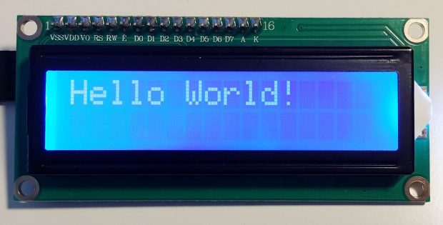Liquid Crysal Display (LCD): - There is a 16x2 LCD used to display the result of the process riggers by the user. It has 16 columns and 2 rows, also, a SoC which is used in 4bit feed procedure by the Arduino and a contrast control with a 10K potentiometer.

Fig. 2.2.1.2 16x2 LCD [4]

* 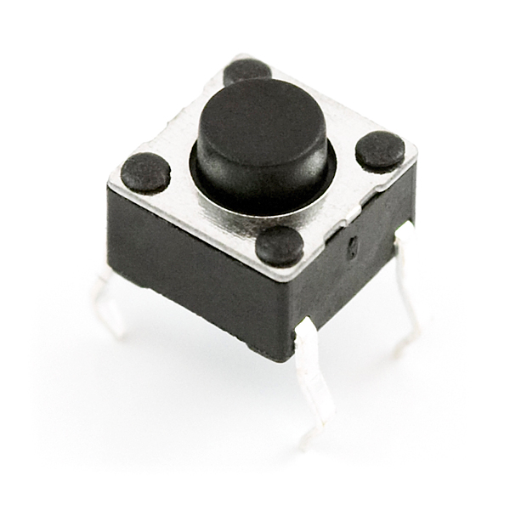Buttons: - They type of buttons used in this project are of push type. So, when you push the button the internal circuit gets triggered and the connection is completed. They are used to select a particular loop/sub-loop/subsystem inside the Simulink file.

Fig. 2.2.1.3 Push Button [5]

* 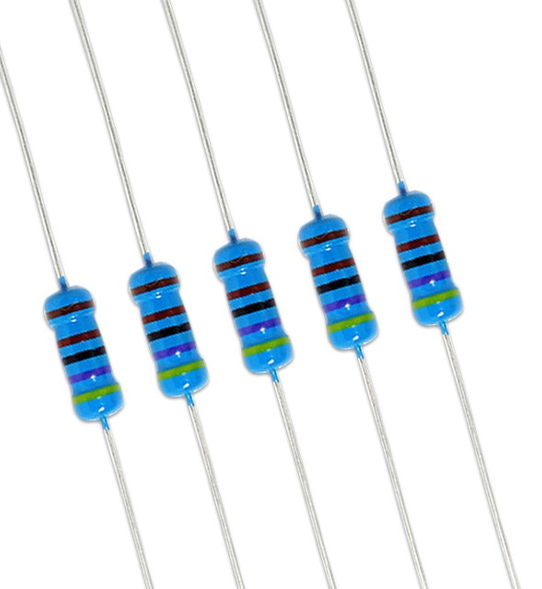Resistor: - A resistor is basically a passive electrical device to drop voltage or limit current. Here we have used 220Ohm resistor for the buttons and LCD and one 10K Ohm potentiometer for contrast variation for the LCD. The purpose of the resistor is o hold the value and limit overall current from supply to the Arduino pin.

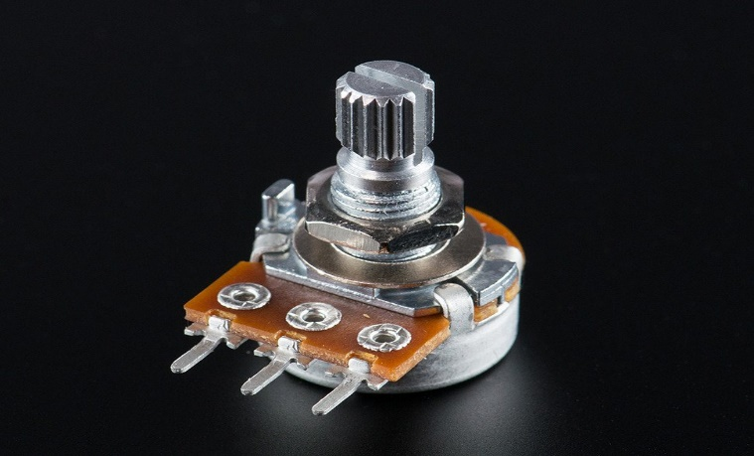Fig. 2.2.1.4 Resistor [6]

Fig. 2.2.1.5 Potentiometer [7]

* 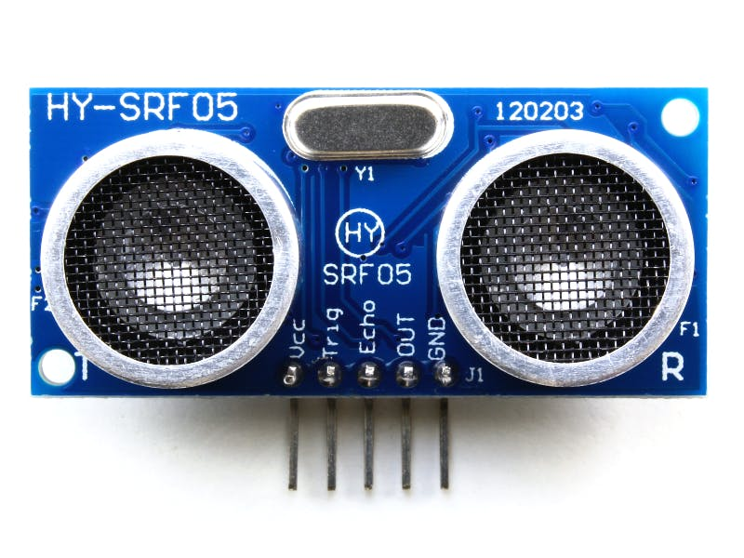Ultrasound Sensor: - The ultrasound sensor used is HC-SR04. It has a working frequency of 40KHz. The sensor has a trigger and an echo pins and the Simulink ultrasound block calculates the distance using the signals from the pins.

Fig. 2.2.1.6 HC-SR04 [8]

* 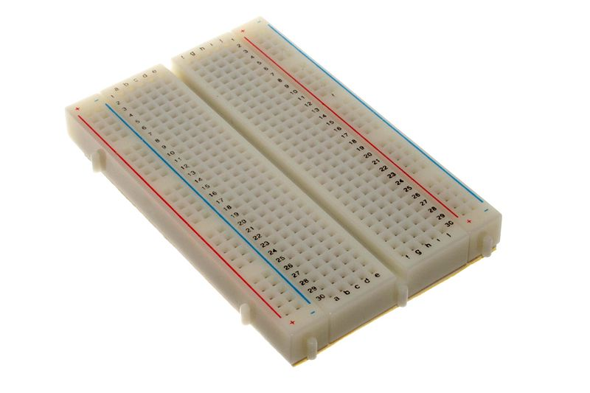Breadboard: - It is a solderless board with certain internal connections. We can spread out and connect different components in serial or parallel manner.

Fig. 2.2.1.7 Breadboard [9]

**2.2.2 Software and Simulink Blocks**

* 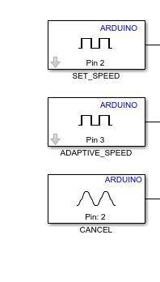**Blocks**Input Pins: - These are the blocks which can be used to receive a signal from the Arduino pins. The project has five inputs from the Arduino UNO. Each of them initiate a specific task/block. We have different buttons like Set_speed, Adaptive_speed, Cancel, Increase_speed and Decrease_speed.

Fig. 2.2.2.1 Pin Blocks

* 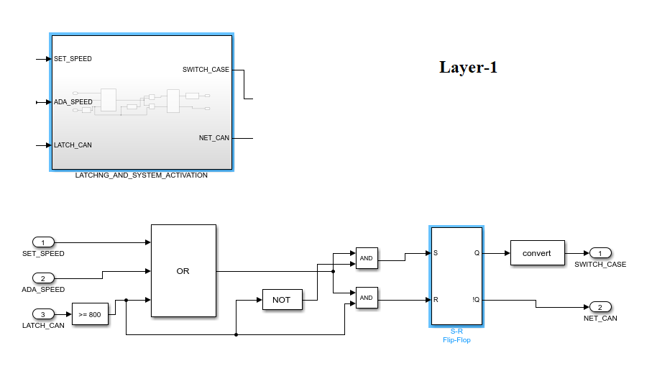Latching Logic: - The project requires continuous execution on a particular trigger. The trigger occurs only once but the execution of the corresponding block needs to happen until next trigger. Hence we included the latching logic which make sure that a particular block’s is always selected after he trigger goes off.
* Fig. 2.2.2.1 Pin Blocks 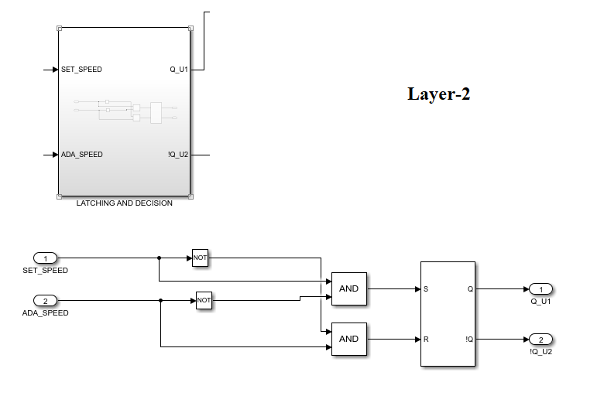

Fig. 2.2.2.2 Latching Layer 1

Fig. 2.2.2.3 Latching Layer 2

* 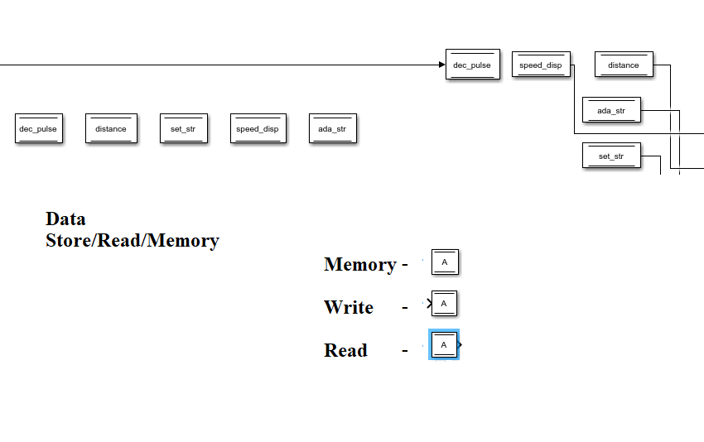**Data Memory/Read/Write: -** Used for routing a signal in or out of particular block(s). Enables a user to use the same signal at multiple places.

Fig. 2.2.2.4 Data Stores

* 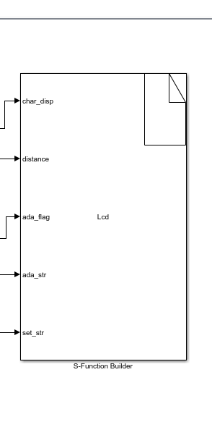**LCD Block: -** This block is designed to display the content and makes it readable to the user. Also, there are certain other tasks which are programmed into it.

Fig. 2.2.2.5 LCD Module

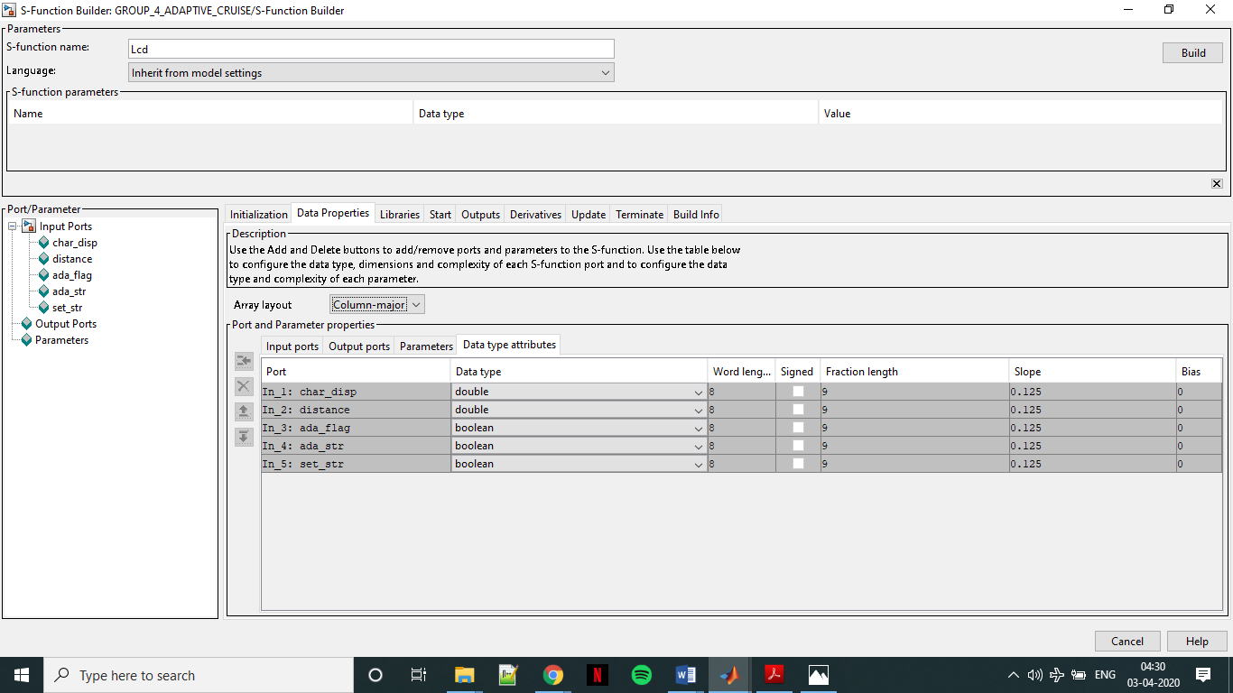 Fig. 2.2.2.5 Internal S-Block

* 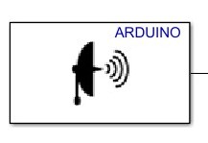Ultrasound: - The block forwards the distance signal. It is connected to a 4 pin HC-SR04 Ultrasound sensor. The block calculates the distance and gives it as the output.

Fig. 2.2.2.6 Ulrasound

* 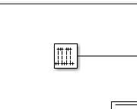**Pulse Generator: -** This block is providing the pulse to the manual cruise mode. The increase and decrease enables system act when they receive this pulse. It is running at rate of 0.5. The same pulse is used for auto-decrement too.

Fig. 2.2.2.7 Pulse Generator

**Implementation**

**3.1 Module 1**

The project can be divided majorly into two modules, the hardware and the software. The hardware consisting all the connections and testing of the same using a different coding logic. This ensures that the connections are firm and secure and won’t be altered further as well as signal flow becomes more realizable.

**3.1.1 Hardware**

* 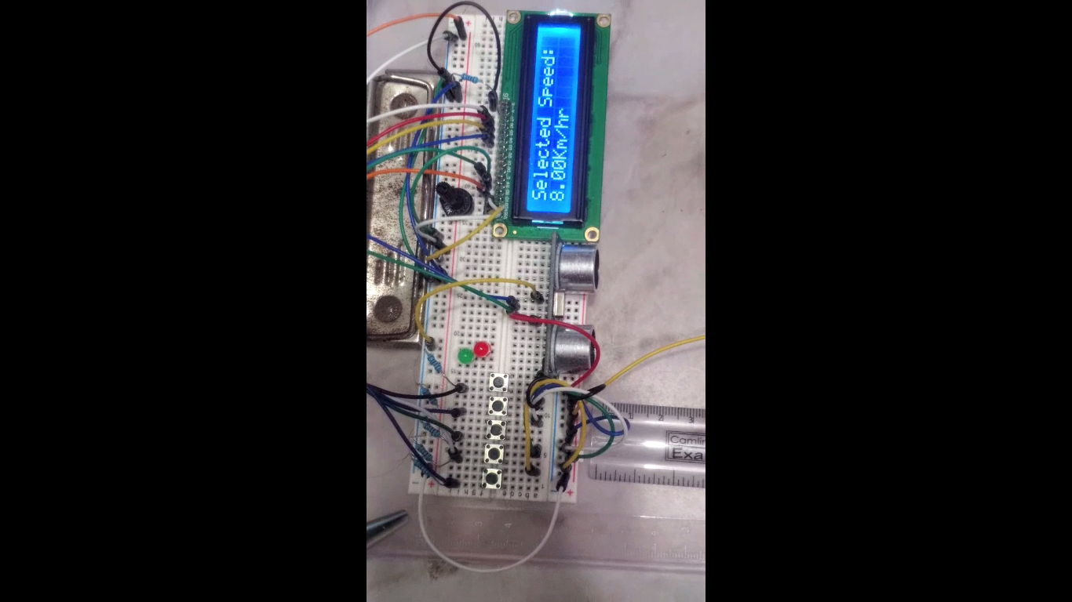First the buttons were connected in a pull down configuration. So the by default value the pin holds is logic ‘0’ or ground. And when the button is pressed the connection is completed and the value changes to logic ‘1’ or Vcc. This is sensed by the Arduino and further execution is done.

220 Ohm

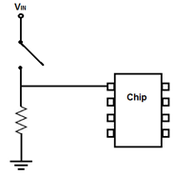 Fig. 3.1.1.1 Buttons

* 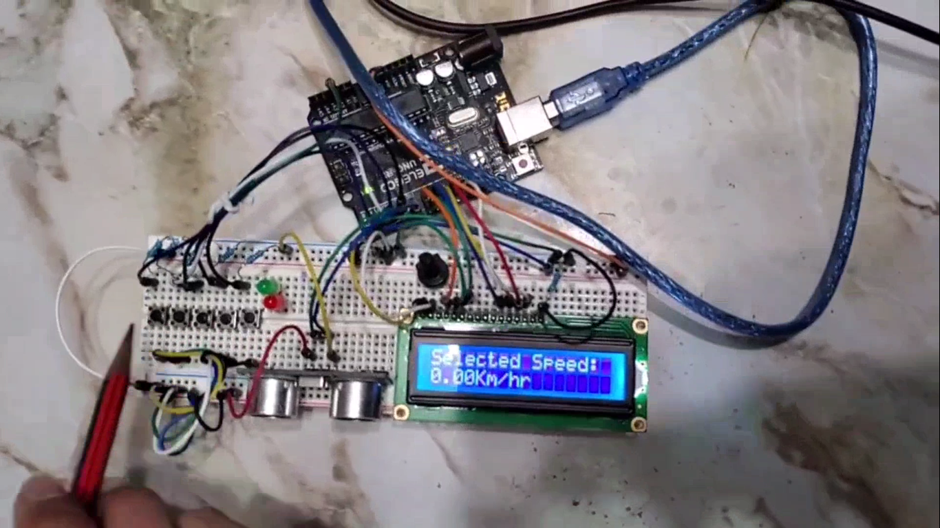Connection to the LCD was done by connecting the 6 pins of the LCD rs, en, D4-D7 to Arduino pins 8-13 respectively. The strings and the data will be provided by the Simulink and will be transferred to the LCD via the Arduino for it to display.

Fig. 3.1.1.2 LCD

* Connected the HC-SR04 to the Arduino. The trigger and echo pins were connected to the pins 4 and 5 of Arduino respectively. The distance value is sent to the Simulink for further processes. Ultrasound waves are used for the purpose of calculating the distance.

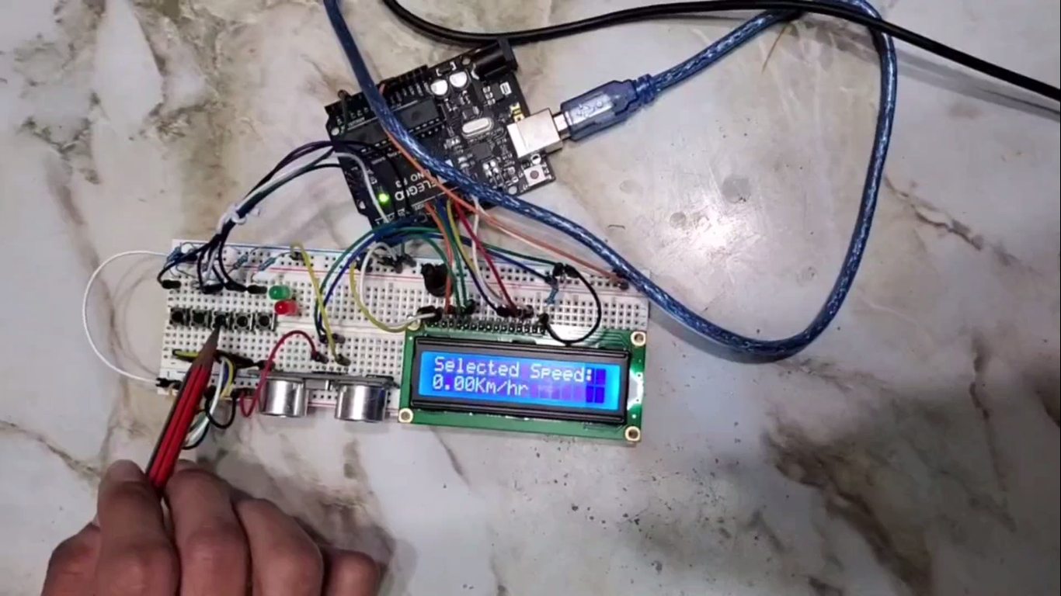Fig. 3.1.1.3 Sensor

* Final assembly resulted in a proper working system for the software to execute the designed program.

Fig. 3.1.1.4 Final Assembly

* 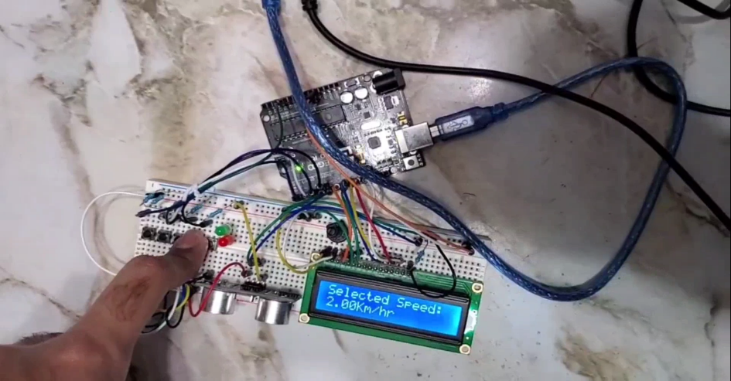Set_speed is used to enter the cruise mode. The increase and increase buttons are needed to be pressed in order to increase or decrease the speed.

Fig. 3.1.1.5 Demo

* 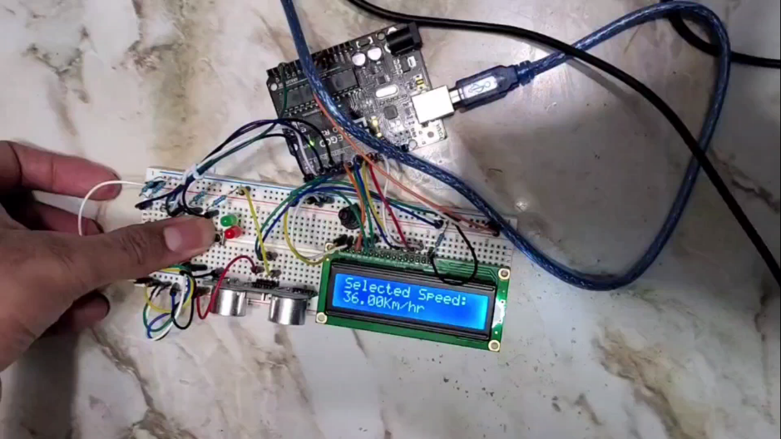The moment we enter adaptive mode the system goes autonomous. The speed is changes based on the distance value.

Fig. 3.1.1.6 Adaptive

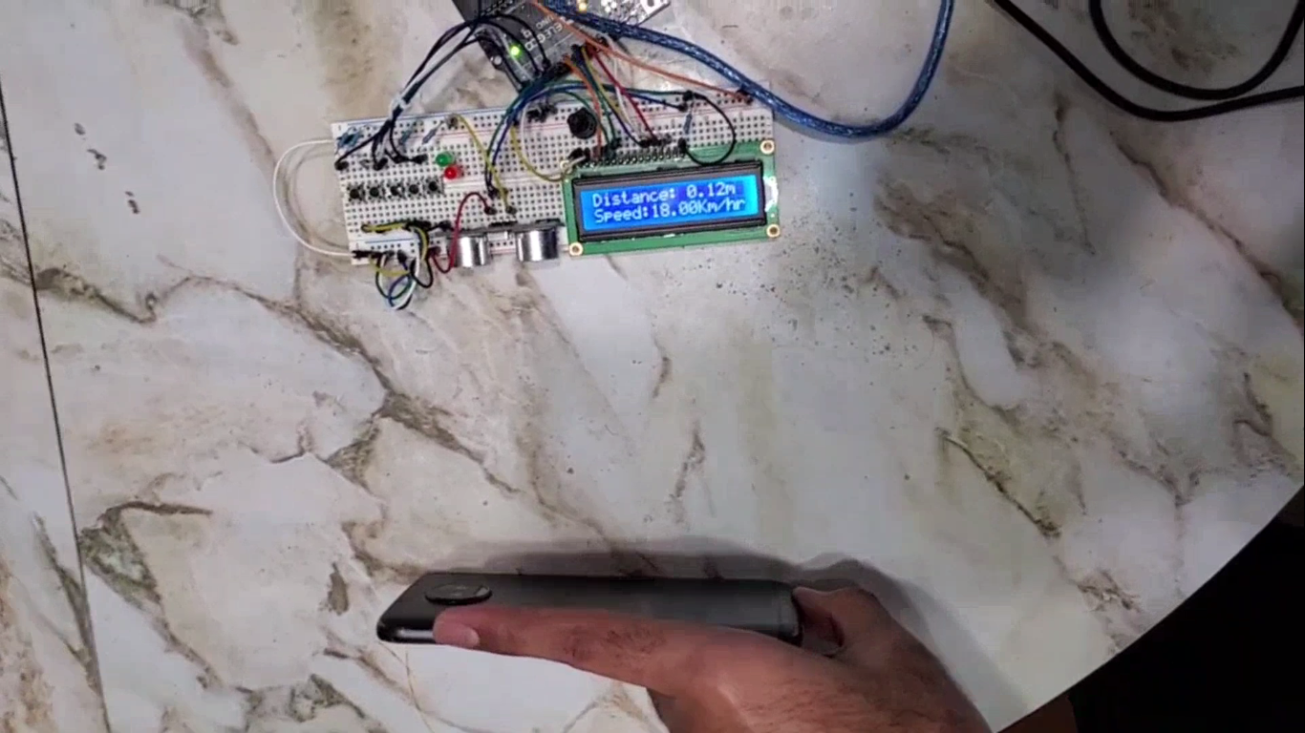

Fig. 3.1.1.7 Adaptive Demo

**3.2 Module 2**

This module consists of 3 sections which are the 3 layers of the software part of the program. The Simulink model is responsible for all the processing and the calculations. Which are then forwarded or received by/to the Arduino board.

**3.2.1 Layer 1**

* 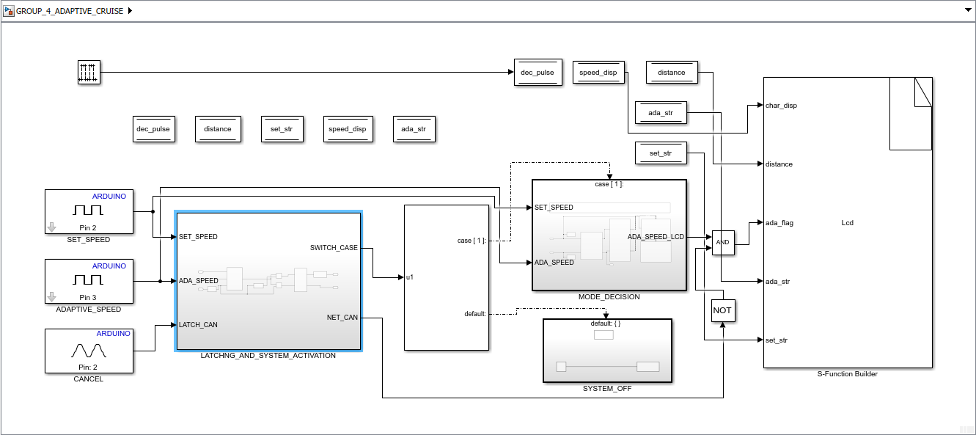This is the foundation layer which makes sure of the latching and triggering of the entire project. Also as it is the root layer it contains the memory blocks, due to which they are accessible by all the elements of Simulink. The pulse generator and LCD module are present too in the same layer.

Fig. 3.2.1 Layer 1

**3.2.2 Layer 2**

* 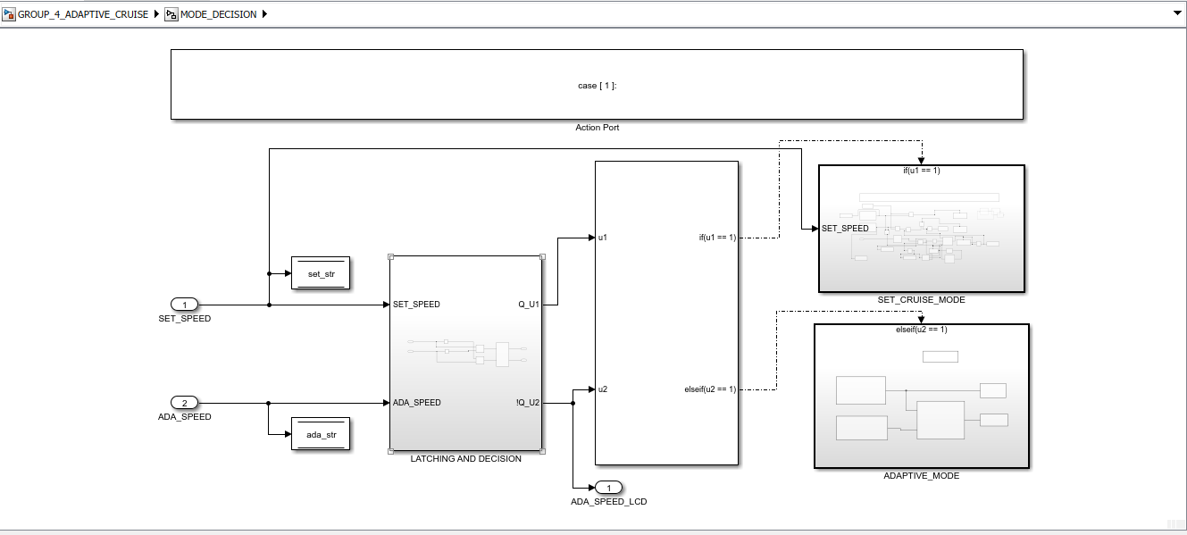The layer 2 is simply a decision maker which decides which part of the system will be accessed, the manual or the adaptive part.

Fig. 3.2.2 Layer 2

**3.2.3 Layer 3**

* The layer 3 is 2 sub-sections of layer 2. It has 2 parts, a manual and an adaptive part. Depending on the trigger from layer 1. Either is chosen by the layer 2 to be executed.
* Sub-Section 3a
  + 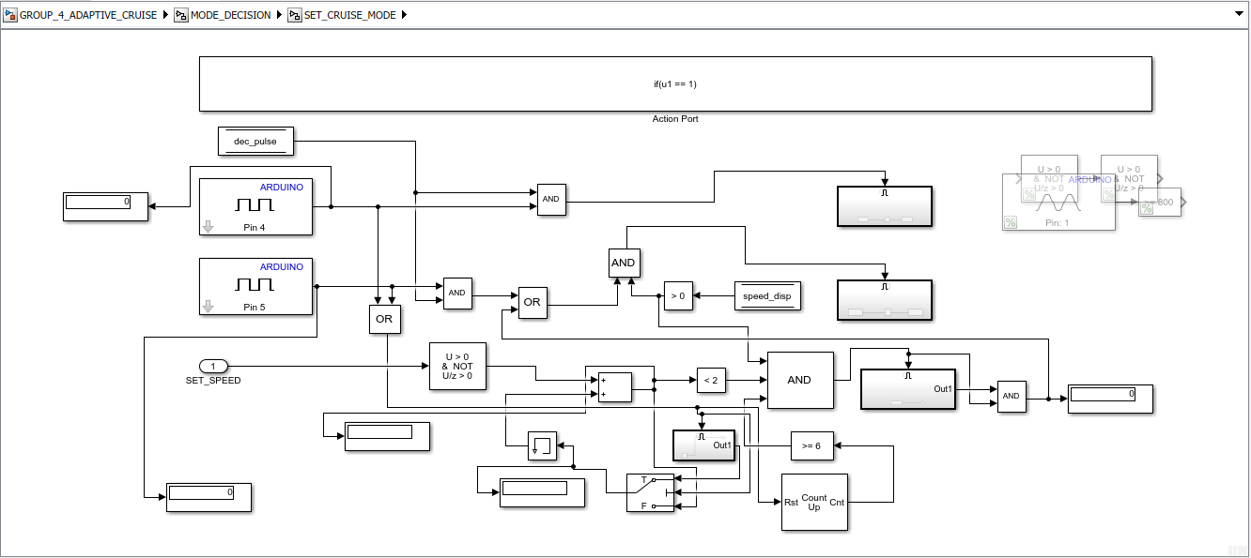This part has the logic for manual and auto decrement. The section increases speed for increase_speed button and decreases speed for decrease_speed button. There is waiting time of 3 seconds, if by then the set_speed button is not pressed he system will bring down the speed automatically.

Fig. 3.2.3.1 Sub-Section 3a

* Sub-Section 3a
* 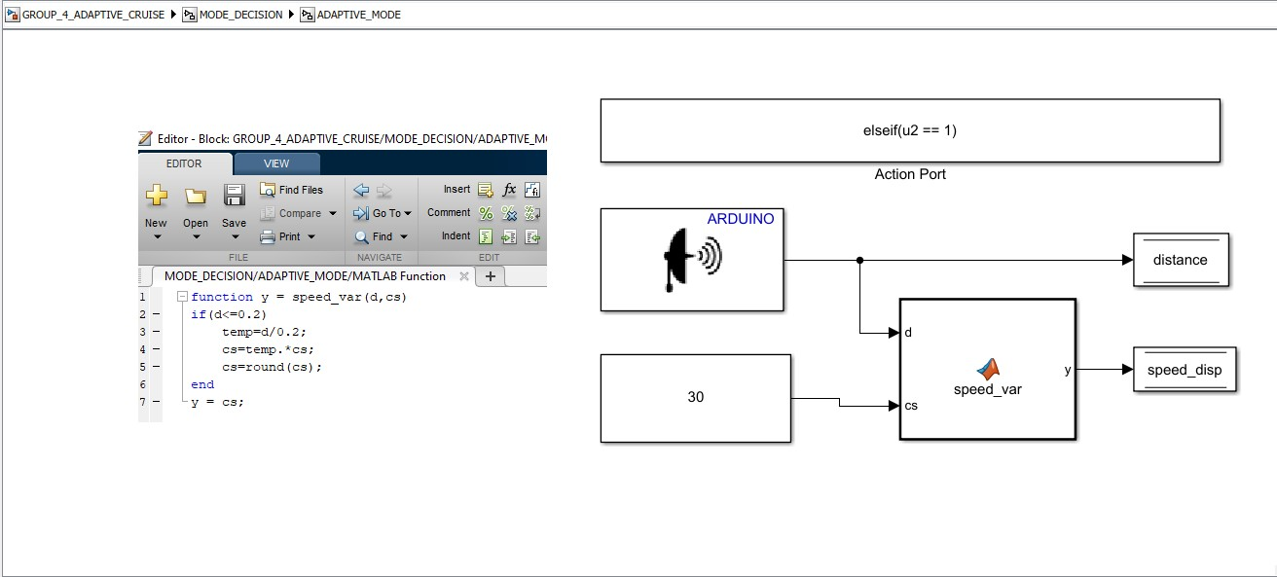This part has the clock combination for the adaptive mode. Once the system enters he adaptive mode. It will automatically adjust its speed depending on the distance value it receives from the distance block in Arduino. The barrier for action is kept at 0.2m (for demonstration purposes).

Fig. 3.2.3.2 Sub-Section 3b

**Challenges Faced**

This section will be describing the challenges faced while designing the project. There were many obstacles which were hurdled through in order to get the complete result. These majorly include LCD, Signal routing etc.

* **LCD**:
  + **Challenge:** MATLAB doesn’t have its own LCD module for external simulation, which can be used in the project. It does contain and LCD block but only for normal/in-system simulation and can’t be deployed in the Arduino board. LCD stands for, which we will be interfacing with our Arduino hardware setup. As the professor asked if we can use LCD with Simulink and Arduino, we decided to proceed further and give it a try, even though as a matter of fact we knew it would not be easy.
* **Challenge Handled:** Construction of the LCD module using the S-Block Builder in Simulink. This enabled us to transfer numeric data from the model to the LCD via Arduino. Although, strings couldn’t be transmitted, as it a restriction of the Simulink software and incompatibility between the S-Block builder and string library modules

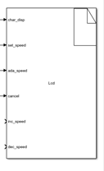

Fig. 4.1 LCD

* **Data Routing**
  + **Challenge:** Just like any other technical project, this adaptive model is a combination of hardware as well as software too. A con of doing it on Simulink is that unlike Arduino IDE, we cannot write a variable, assign a value to it and use it in or model as and when we require. But, in this project, certain blocks/sub-systems are supposed to be triggered only when a certain button is pressed.
  + **Challenge Handled:** We used the memory blocks and assigned each of them to different sub-systems as we required. Each come with a set of read, write and store sections. The read and memory is used once while write is used multiple times as per the requirement

Fig. 4.2 Data Store

* **Arduino Pins**
  + **Challenge:** Arduino UNO has 14 digital (D0-D13) and 6 analog (A0-A5) hardware pins for IO, PWM, Serial Communication handling. When we use UNO with IDE, we have all the14 pins at our exposure and we can set them up as per out needs, but, unlike IDE, Simulink does not allow us to do. While using the UNO with Simulink, it reserves the digital pin D0 and D1 for serial communication and if they are assigned to some other task, an error is raised in the ‘Diagnostic Viewer’ of Simulink. We require 6 pins for LCD and 2 for the ultrasound sensor, leaving with only 4 pins for the buttons (5 buttons)
  + **Challenge Handled:** As the buttons work in pull-up configuration which is digital in nature, we switched all the last inputs to the A0 section and attaching a comparison block of limit 800 which gives the same value like a digital read would have given enabling us to perform naturally

Fig. 4.3 Arduino Pins

* **Continuous Execution**
  + **Challenge:** It was challenging to develop a system which would continuously run one single section. Which made sure that once he trigger occurs the system goes in to the system, but, when the trigger goes off, the model should remain in the same section.
  + **Challenge Handled:** The use of latching logic helped us out. The latching logic is basically a SR-Flip-flop which would be triggered on a certain combination of input.

**Fig. 4.4 Latch**

* **Continuous Decrement** 
  + **Challenge:** The model had one condition in the manual mode. The condition was, the speed should decrease automatically if it is not fixed by the set_speed button. Which made it complicated, as Simulink dosent support ‘pause()’ function. Which could make it wait for the trigger, ideally.
  + 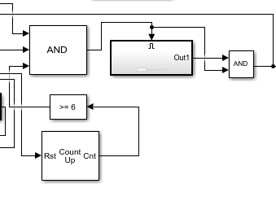**Challenge Handled:** We introduced a combination of pulse generator and comparator block. The pulses count for total of 6 seconds before activating the auto-decrement section for sending out the pulses to decrement the speed.

Fig. 4.5 Continuous Decrement

**Functioning**

* 1. 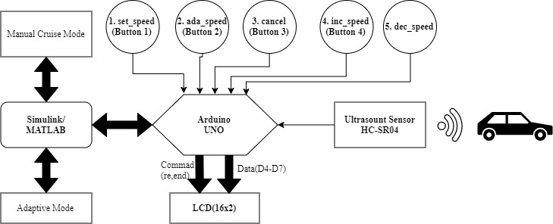**Block Diagram of Project**

Fig. 5.1 Block Diagram [10]

* 1. 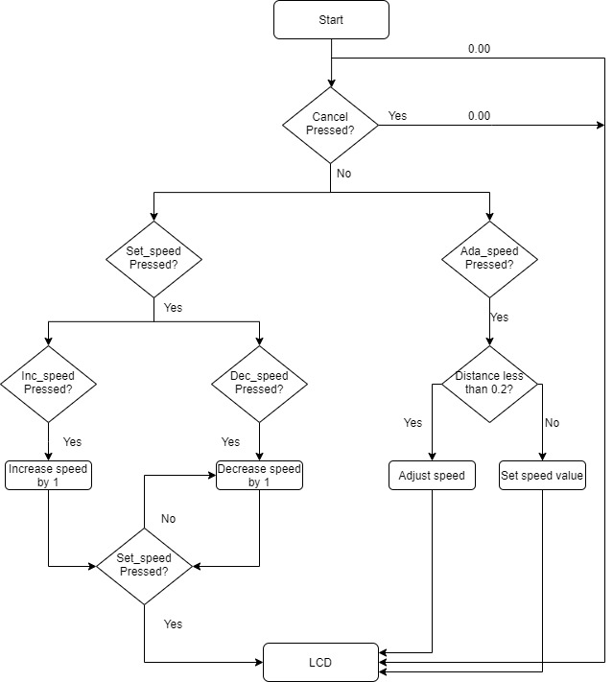**Flowchart of Adaptive Cruise Control**

Fig. 5.2 Flowchart [11]

* 1. **LCD S-Block Code**
* s we need to create a S-Block which will run as an LCD module there was some in-programming needed to be done. So the S-Block code was written to display execute considering other flags.

#include <math.h>

#ifndef MATLAB_MEX_FILE

#include "LiquidCrystal.h"

#include "LiquidCrystal.cpp"

LiquidCrystal lcd(8, 9, 10, 11, 12, 13);

#endif

#ifndef MATLAB_MEX_FILE

lcd.begin(16,2);

if (set_str[0]==1)

{

lcd.setCursor(0,0);

lcd.print (F("You have entered"));

delay(800);

lcd.setCursor(0,0);

lcd.print(F("Cruise Mode "));

delay(800);

}

lcd.setCursor(0,0);

lcd.print(F("Selected Speed: "));

lcd.setCursor(0,1);

lcd.print(char_disp[0]);

lcd.print("Km/hr");

if (ada_flag[0]==1)

{

if (ada_str[0]==1)

{

lcd.setCursor(0,0);

lcd.print (F("You have entered"));

delay(800);

lcd.setCursor(0,0);

lcd.print(F("Adaptive Mode "));

delay(800);

}

lcd.setCursor(0,0);

lcd.print(F("Distance: "));

lcd.print(distance[0]);

lcd.print("m");

lcd.setCursor(0,1);

lcd.print(F("Speed:"));

lcd.print(char_disp[0]);

lcd.print("Km/hr");

delay(35);

}

#endif

**5.4 MATLAB Code for Speed Control**

* As per the distance the speed needs to be adjusted, hence a small MATALB code block is used for the same.

function y = speed_var(d,cs)

If (d<=0.2)

Temp=d/0.2;

Cs=temp*cs;

Cs=round(cs);

end

y=cs;

**Results**

The Simulink model can successfully change the speed for the chosen mode. The variation rate is fixed but not the limit. Currently there is no limit to the speed. It can be taken as high as one wants, but won’t go under zero. In order to deploy the model in practical life there should be a limit imposed on it. Also, the adaptive mode, the sensor used provides an accurate data of the distance between it and the further object. This is used to determine the speed.

**References**

[1] http://ctms.engin.umich.edu/CTMS/index.php?aux=Basics_Simulink

[2] https://create.arduino.cc/projecthub/products/arduino-uno-rev3

[3] https://oneguyoneblog.com/2016/08/08/geekcreit-uno-16x2-lcd-display/

[4] https://www.sparkfun.com/products/97

[5] Res https://www.pchcables.com/63-1039.html

[6] https://www.adafruit.com/product/562

[7] https://en.wikipedia.org/wiki/Breadboard#/media/File:400_points_breadboard.jpg

[8]https://create.arduino.cc/projecthub/Nicholas_N/distance-measurement-with-an-ultrasonic-sensor-hy-srf05-64554e

[9] https://app.diagrams.net/

[10] https://app.diagrams.net/